Modelling crowd dynamics phenomena

Annually there are many events which attract thousands or even millions of people, such as Lowland and the Hajj pilgrimage. Daily, millions of people use public transport hubs or shopping malls. They make up huge crowds that have to be managed, such that the infrastructure is used efficiently and safely. Models are used to predict crowd dynamics fast and accurately.

Within the chair of Operation & Management of Transport Systems (department of Transport & Planning, Faculty of Civil Engineering and Geosciences, Delft University of Technology) we have developed a new model. Just like reality, our model shows interesting emerging behavior, where patterns occur through the interaction between pedestrians which themselves do not show these properties. Examples include lane formation in bidirectional flows and clogging in front of doors.

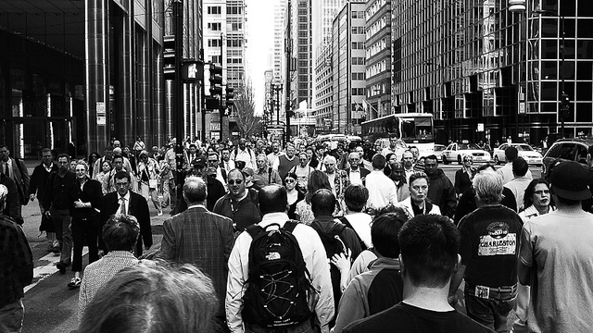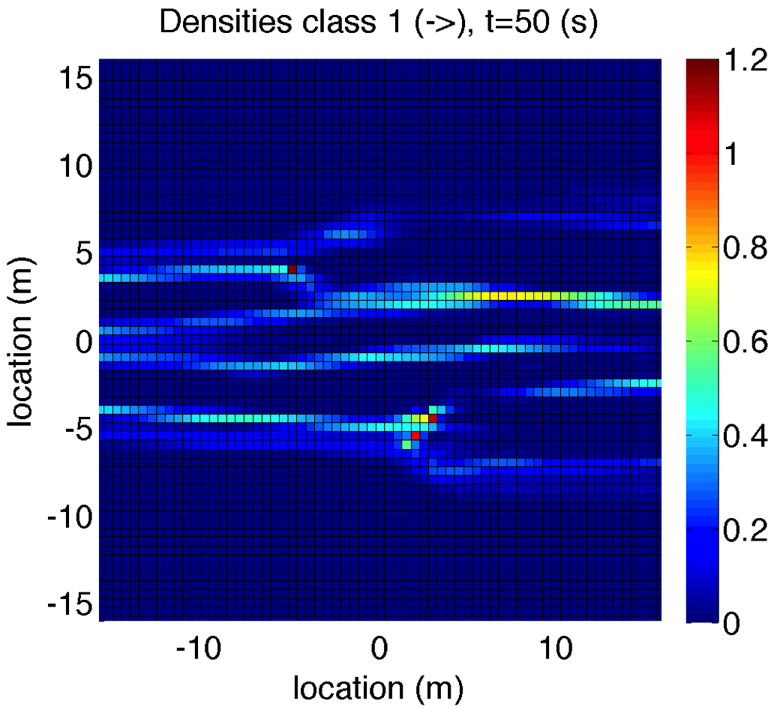
Real life bidirectional flows and simulated bidirectional flows.

The project aims at improving our crowd dynamics model. It could focus on either of the following research questions:
- How to improve the numerical methods such that computations can be done more efficiently? We are in the process of converting from a fixed to a moving coordinate system, which could be one of the research directions.
- How can we improve the model to exhibit more realistic patterns? Our preliminary results show transitions from stable to chaotic behavior, depending on the settings of certain parameter values. We would like to get more insight into these transitions, understand when they occur and compare them with transitions seen in reality.

Key words: crowd dynamics; pedestrian flows; modelling; simulation; emerging patterns; self-organisation

For more information, please have a look at http://www.pedestrians.tudelft.nl or contact either of the persons listed below.

Dr.ir. Femke van Wageningen-Kessels (f.l.m.vanwageningen-kessels@tudelft.nl)
Dr.ir. Winnie Daamen (w.daamen@tudelft.nl)
Prof.dr.ir. Serge Hoogendoorn (s.p.hoogendoorn@tudelft.nl)

