# Stability analysis in a model of the human inner ear, part 3

Project proposal

In the 1980s a computational (numerical) model of the human inner ear was developed in a cooperation between the depts. of Biophysics and Applied Mathematics at the RuG. This model consists of a number (~400-1000) individual sections behaving as harmonic oscillators, where the excitation *ζ* is governed by an equation of motion of the shape:



where *m* is the mass of the section, *s* a stiffness restoring the section to its resting position and *d* a damping term. The driving force is represented by *p* and is a fluid pressure. All oscillators are coupled via an incompressible and inviscid fluid, and the values of *s* and *d* vary with the location of the oscillator. The equation



follows from conservation of mass in the fluid, where *A* is a surface area of a fluid channel, *ρ* the fluid density and *bBM* the width of an oscillator. The two equations are combined to



a second order differential equation in time and place. Using a central difference for the derivatives in place a system of coupled second order differential equations in time results.



This is solved using a Runge-Kutta 4 time integration method, where in each step the coupling is resolved by a Gauss elimination of the equation **Ap**=-**Bg**.

The Runge-Kutta 4 method was chosen on the basis of its stability region. It can be shown that the stability of the RK4 for a single oscillator is governed by:



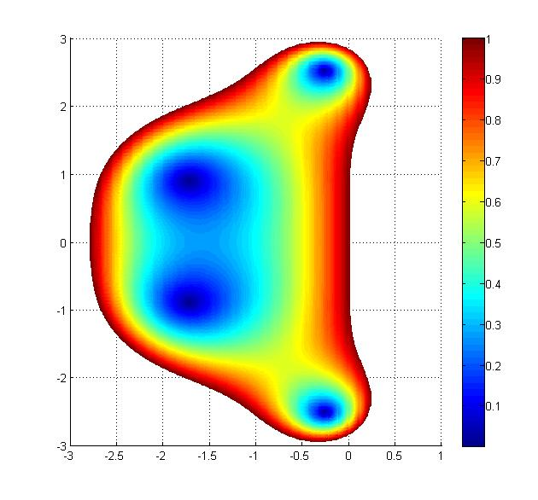This function is shown here. It can be seen that a substantial portion of the imaginary axis falls within the stable region. This is important since the object of the implementation was to study limit cycle oscillations for very small and even negative values of the damping d.

### project part 1:

For this model a stability analysis was carried out by Kimberley Lindenberg (see Kimberley’s report), showing the RK4 time integration method to be more stable than a Modified Sielecki method. However, contrary to what was suggested in the literature, the increased stability did not warrant the larger computational effort required for RK4.

By the end of the 1990s an important alteration was made to the equation of motion of the individual oscillators. Analysis of measurements of the excitation inside the real inner and inverse modeling led to the equation:



where the damping d has a negative value and the term *s’ζt-τ* is a delayed feedback stiffness which serves to stabilize the otherwise unstable system of equations. Attempts to implement this function in the numerical model led to severe stability issues and a preliminary stability analysis (see attached document on Impedance) led to the conclusion that each individual oscillator in a model with this equation of motion is unstable, but linking it to neighboring oscillators provides stability. Therefore all oscillators in the model are stabilized except the ones at the ends, which have no neighbors. A simple adaptation at both ends solved the stability problem.

The model with the negative damping and feedback stiffness has since been used effectively to model various physiological and psychophysical data. Plans are developed to use this model in an extensive study of the effects of damage to oscillators in the inner ear. This brings up several questions:

- if neighboring sections have altered mechanics, when do they stop having their stabilizing influence?

- what are the most efficient choices for the discretization (in both x and t) which still lead to a stable (numerical) model?

The introduction of the delayed feedback stiffness makes the differential equation into a so-called Delayed Differential Equation (DDE), of the form:

$$U^{'}\left(t\right)=f\left(t,U\left(t\right),U\left(t-τ_{1}\right),U\left(t-τ_{2}\right)\right) t≥0$$

$$U\left(t\right)=0 t≤0$$

### project part 2:

Stability analysis of DDEs is considerably more complex than for ODEs (ordinary differential equations). Initial steps for a stability analysis of DDEs were made in the work of Melissa Wijchers, using the method of steps.

## This project

The goal of the current proposal is to use the method of steps, as described in the work of Melissa Wijchers, in combination with the work of Kimberley Lindenberg on the original ODE system, to develop a stability analysis for the new system with DDEs. Both an analysis of the ‘analytical’ stability of the system of DDEs and an analysis of the stability of the discretized system will be required.

Using these methods we can establish for which parameter choices a stable solution is possible, and which discretization is required in place and time to achieve a stable numerical method to approximate this solution.