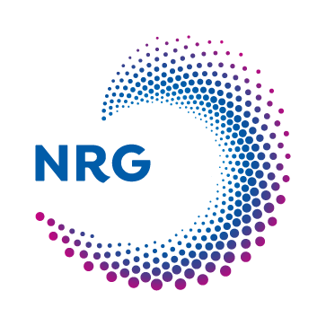
NRG is looking for an BSc/MSc thesis/internship student for:
AI-driven turbulence modeling of two-phase flows in nuclear reactors
Background
The Nuclear Research and Consultancy Group (NRG) is responsible for a continued nuclear research effort in the Netherlands. A significant part of that effort is dedicated to thermal-hydraulic analysis of nuclear reactors during accident scenarios, to improve safety. Many postulated accident scenarios will exhibit two-phase flows, such as bubbles formed in a reactor core or steam flow in the hot leg of the reactor vessel. A proper understanding of such two-phase flows is thus important
Simulation of realistic thermal-hydraulic flow scenarios in reactors is only computationally feasible using the Reynolds-Averaged Navier-Stokes (RANS) approach, in which averaged equations are solved instead of a local instant formulation. This cuts computational costs dramatically but requires advanced models which capture the physics lost as a result of averaging. For single-phase flows, reasonably accurate RANS models have been extensively developed. For two-phase flows, however, RANS models are lacking accuracy.
A possible route to improve two-phase RANS models is using so-called Physics Informed Machine Learning (PIML) techniques, in which high resolution Direct Numerical Simulation (DNS) data is leveraged to train a RANS model. In this way, an AI-driven turbulence modelling methodology is established. In this challenging MSc. thesis project, we will investigate the pioneering work of Wang et al. [1] and apply it to the development of improved two-phase RANS models using PIML. The work will be centered around DNS and RANS simulation of vertically stratified two-phase flow. First, such flow is studied by assuming a flat interface as depicted in Fig. 1. Later in the project, this assumption is removed and the dependence of the PIML-driven turbulence modeling on interfacial instabilities is studied.
The project location will be at NRG’s site in Petten, the Netherlands. NRG offers a monthly allowance, as well as compensation for housing and transportation for the period of your stay.
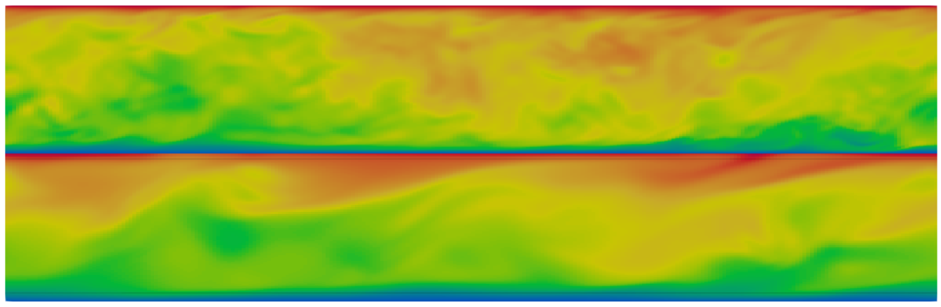
Fig. 1: Vertically stratified two-phase turbulent flow, in which each phase (separated by a horizontal interface in the middle of the domain) is solved in its own non-dimensional form. The upper fluid is air and the lower fluid is water.

Objectives/Results
- Investigation into Wang’s PIML technique
- Application of PIML to the development of improved two-phase RANS models for non-deforming interfaces
- Integration of the PIML Reynolds stress tensor closures in a RANS model
- Extension of the PIML approach to deforming interfaces
Your profile
- MSc. student in applied mathematics, with specialization in CFD
- Good knowledge of turbulence, multiphase flows, and numerical methods
- Required computer experience: Linux and Python
- Recommended computer experience: Fortran, C and C++
- Fluency in written and spoken English
- Good analytical and problem-solving skills
- Dedicated, good communication and social skills, independent
Our offer
- A challenging thesis project with a scientific scope, to be executed within a successful team with an informal atmosphere and an excellent reputation
- Strong support from enthusiastic members of the team
- Monthly allowance/stipend
- Housing and transportation compensation for the period of stay
Contact details
NRG
Dr.ir. Edo Frederix
frederix@nrg.eu
References
[1] J.-X. Wang, J.-L. Wu, and H. Xiao. Physics-informed machine learning approach for reconstructing Reynolds stress modeling discrepancies based on DNS data. Physical Review Fluids, 2(3):034603, 2017.

