New Wanda matrix solver

Wanda is the commercially available in-house developed simulation package for water hammer in pipeline systems. For more information on Wanda see https://www.deltares.nl/en/software/wanda/

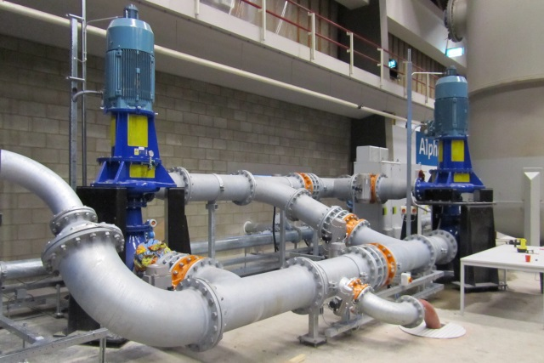
In the user interface of Wanda the user can drag and drop components like pumps, pipes and valves into a diagram and connect them. To simulate water hammer, Wanda internally solves a set of non-linear equation for the head and the discharge. This is done by linearizing the equations via the Newton Rapson method. This results in a linear set of equations, which is iteratively solved until a certain convergence criteria is met. To solve this linear system of equations the IMSL sparse matrix solver is used. However, due to performance issues and bugs we are looking for other sparse matrix solvers.

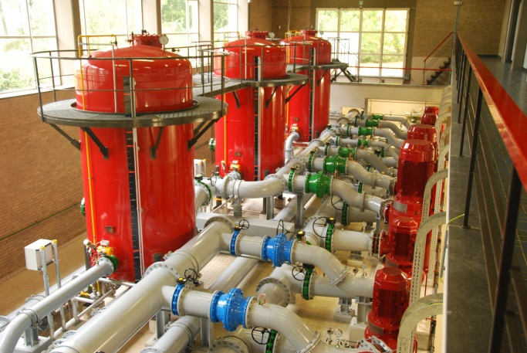
The goal of this assignment is to find best suitable sparse matrix solver for Wanda and to write a Fortran routine to test it.
Questions which should be looked into are:
- How fast is the routine compared to the current sparse matrix solver?
- How does it handle singular matrices, i.e. does it produce a sensible error?
- Is it faster to split the matrix in several submatrices to be solved separately?

For more information contact: Sam.vanderzwan@deltares.nl

